EDUCATION

**Bachelor of Engineering**

Vidyalankar Institute of Technology. Wadala Mumbai

*2020*,

*Courses* Information Technology *61%*

## Diploma

Government Polytechnic Thane

*2014*, *70%*

*Courses* Computer Engineering

**Work Experience:**

|  |  |  |
| --- | --- | --- |
| **Designation** | **Company** | **Duration** |
| Data Analyst | Utkarsh Small Finance Bank | 2.5 year till Now |

# PROJECTS

## Data Lake Project:

## Insert data into DB in UAT and Production.

* Monthly and Daily report generate.
* Manage Datalake Server

**Credit and Debit card Project :**

* Insert data into UAT database
* Validate data from using Python
* Create Dashboard using PowerBi

**Bureau Data Mart :**

* Fetch Data from SFTP
* Store this data to the NAS
* Perform ETL clean the data
* Store this data into PROD DB
* Generate report using Python

**Manage CFR Website development:**

* As Per BRD support for Develop the Website and assign to Business team.

**Covid-19 data Visualization**

* Environment BI Tool: Tableau
* 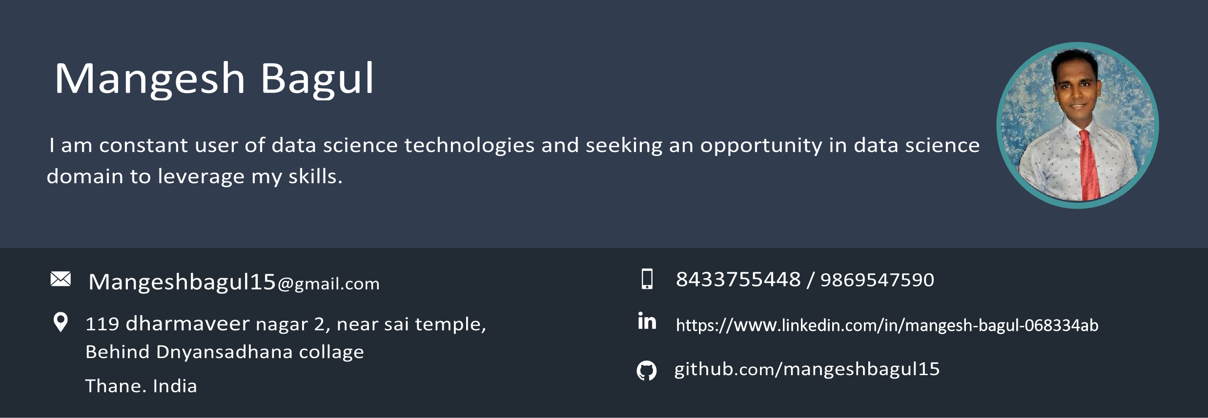Synopsis: This project I have taken covid-19 data set and visualise data in graphical format like bar plot, Pi chart, action perform, dashboard and creating story.

**CIC data Submission:**

* Fetch portfolio data from DB and match from CIC data.
* As per required business logic and share report monthly basis and fortnight.

LinkedIn Skill Assessment Badge for Python

LinkedIn Skill Assessment Badge for SQL

**CERTIFICATES:**

Python From IBM

Analytics with Python (IT Vedant Institute)

SQL (IT Vedant Institute)

Tableau (IT Vedant Institute)

**S**

**KILLS**



PowerBi

PowerBi tableau